**Stats 201 HW5**

1. If we fix other predictor variables (male, momht) as constant, on average, the heights of UCD students will be 0.41213 inches higher if one’s father is 1 inch higher.

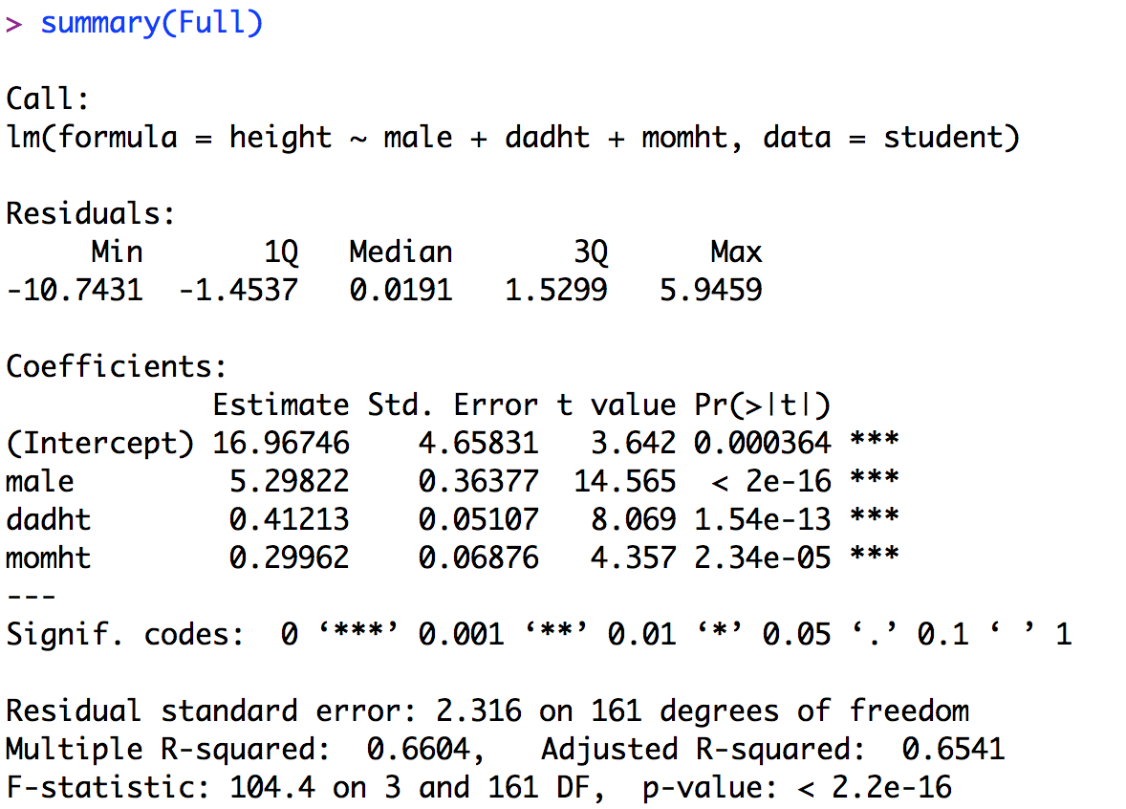

2. H0: β2 = 0, Ha: β2 ≠ 0, p-value = 4.65e-09, conclusion: reject the null hypothesis, and conclude that momht is useful in predicting the UCD students’ heights.

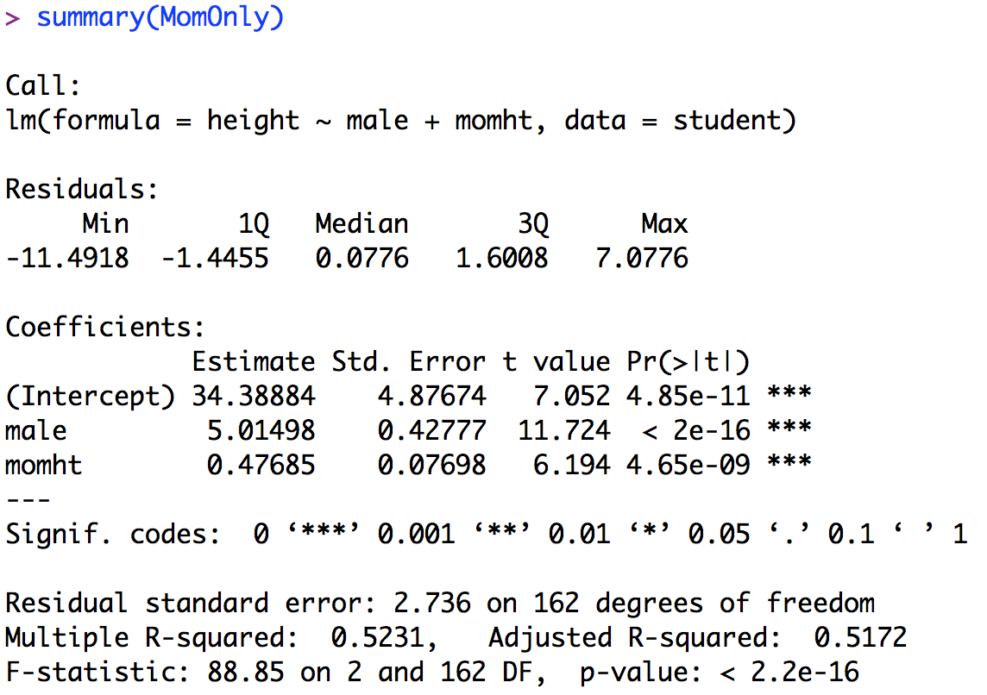

3. If we fix dadht as constant, males will be 5.36620 taller than females on average.

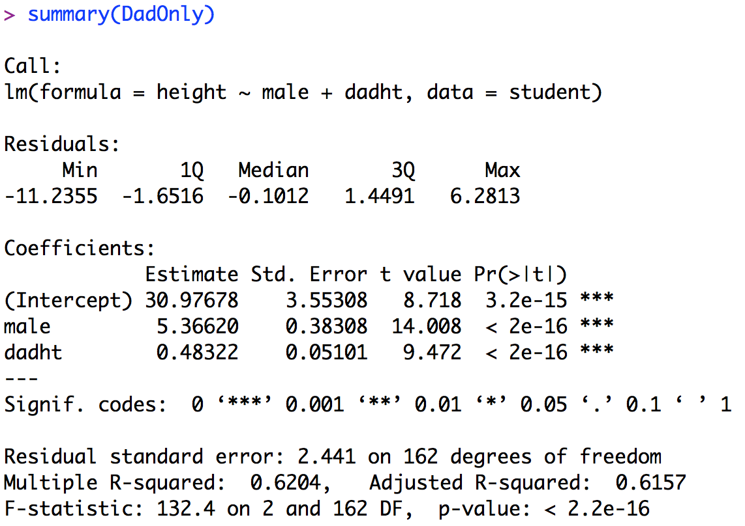

4. Residual against fitted values: we can see that the variance for different fitted values is nearly constant. (But there is an possible outlier 130)

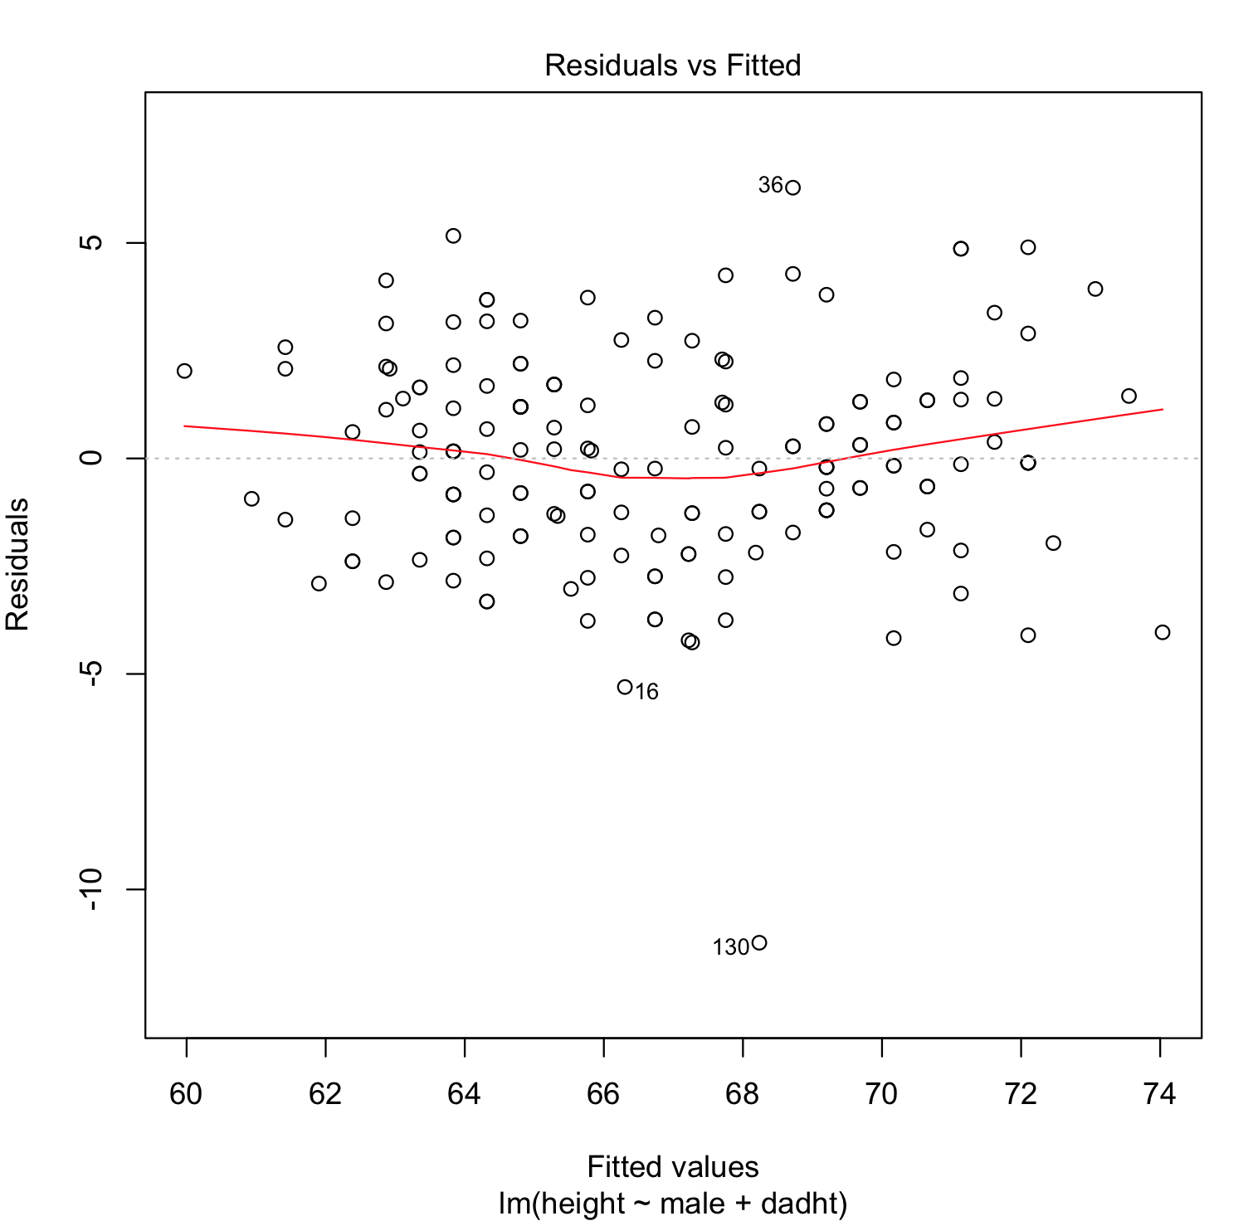

Normal probability plot: the residuals are normally distributed.

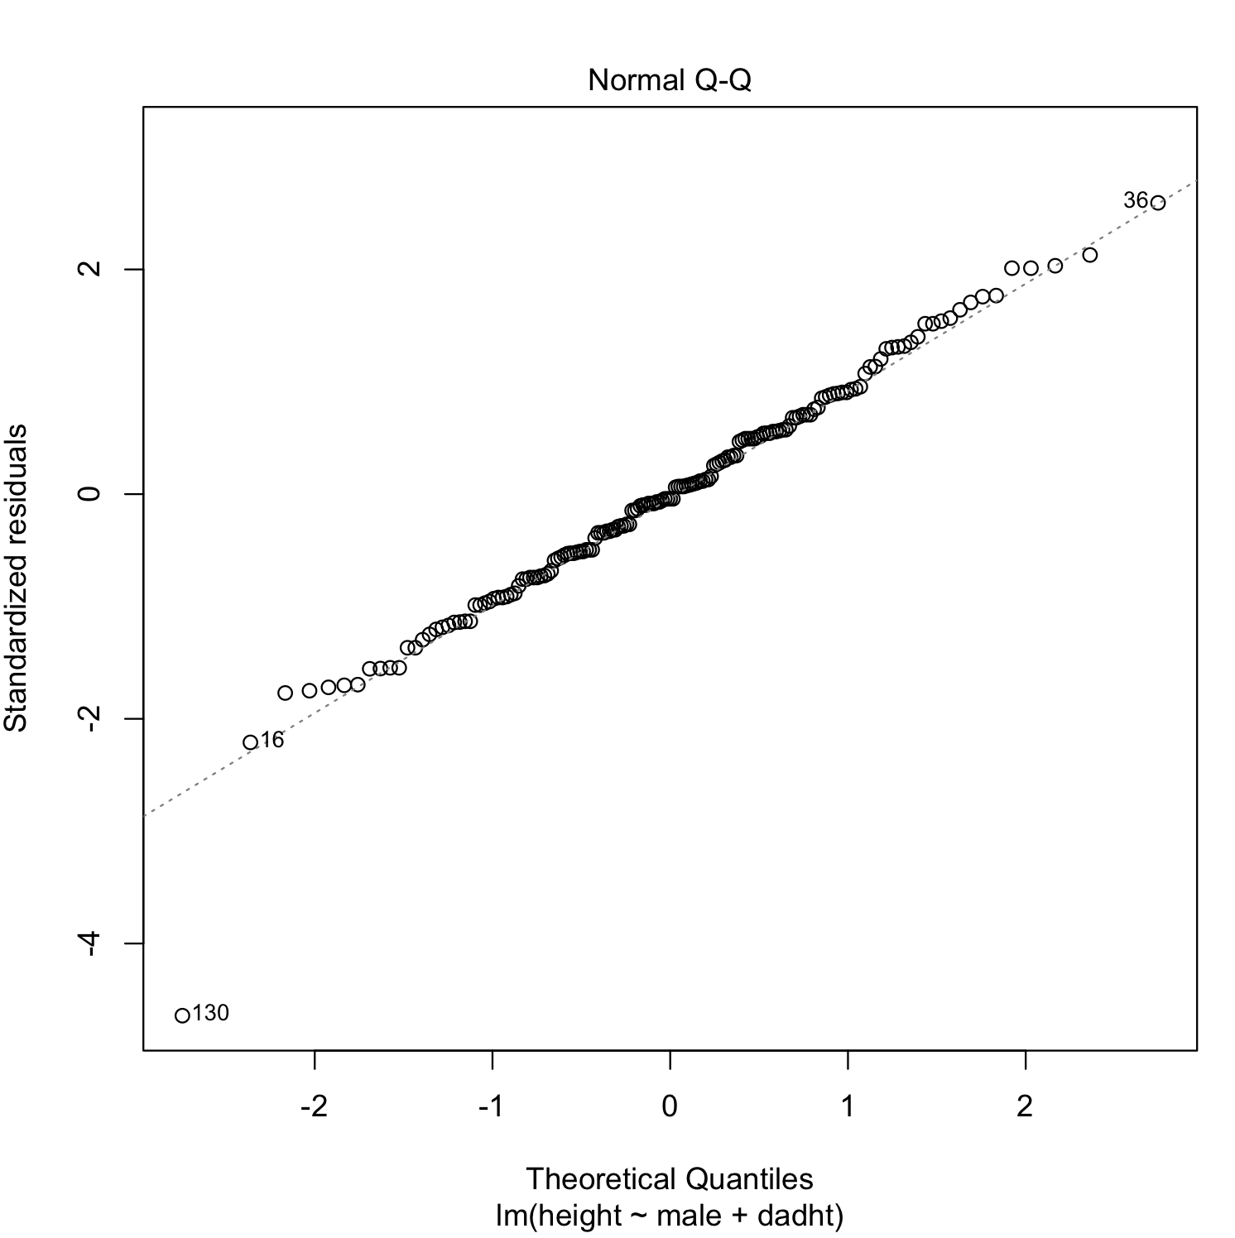

5. It seems like there is a linear relationship between the residuals of DadOnly and momht, so it might be helpful to add momht in the model.

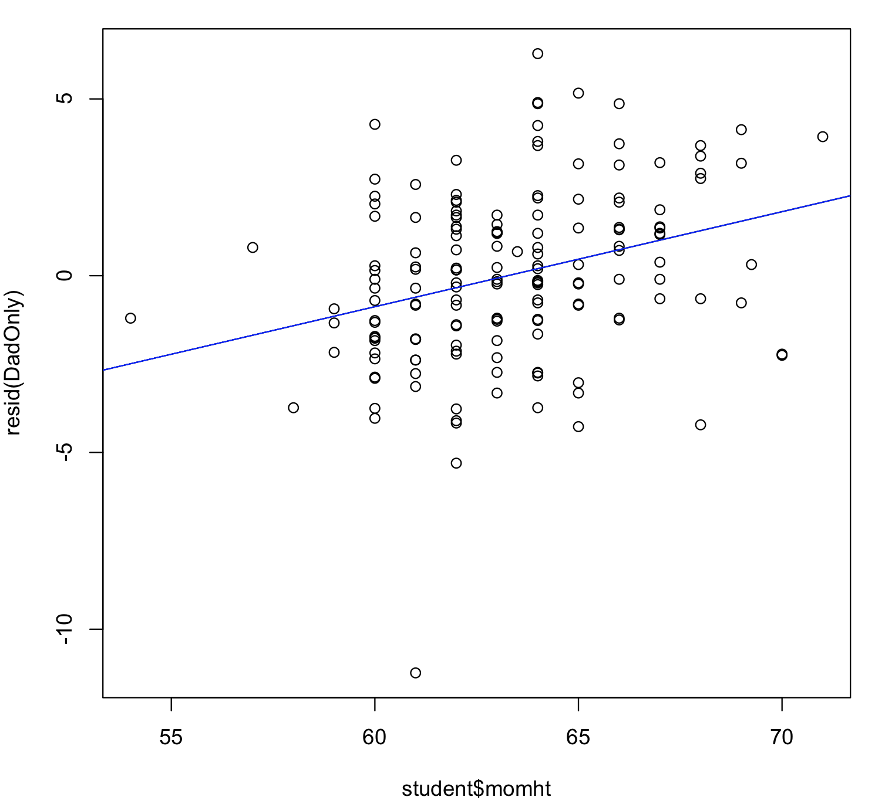

6. The full model is the best because it has the largest adjusted R-Square and smallest residual standard error. The DadOnly model is the second best because it has the second largest adjusted R-Square and second smallest residual standard error.

7. The 95% confidence interval for male is (4.5798389, 6.016597), which means if we hold other predictor variables (dad’s height, mom’s height) as constant, we are 95% confident that the difference between the mean of males’ height and females’ height is in the range (4.5797379, 6.016597).